**South Paulding High School**

**Mythology Course Syllabus**

**\*NOTE: This syllabus is subject to change without prior notice\***

**Instructor: Shayna Harris**

**Email: skharris@paulding.k12.ga.us**

**Phone: 770-949-9221**

**Room: 1016**

**Course description and objectives:** Mythology is an English elective. Its purpose is to provide a broad overview of background and context for an in-depth study of literature. The students will be expected to individually read novels in this class for **four independent reading projects**. (Students WILL be allowed to choose their own novels for these projects). Because the curriculum includes so many different countries’ ancient myths, I will teach these stories in a variety of ways: reading novels, plays, short stories, researching gods and goddesses, creating presentations, viewing clips, and writing original myths.

**Texts:** Provided texts will include selections from various textbooks, as well as full-length novels and excerpts from works such as but not limited to: *Bulfinch’s* *Mythology, Mythology* by Edith Hamilton*, The Power of Myth* by Joseph Campbell, *The Complete Works of Uncle Remus, Fahrenheit 451, The Lightening Thief* and electronic texts/texts from other sources may all be considered.

**Materials:**

Two-pocket (with 3 prongs) folder

Loose-leaf paper, wide-ruled preferred

Pen and/or pencil

Supplies for projects as needed

**Grading: Late Work will be penalized 10 points PER DAY LATE and *will not be accepted* after two weeks from due date.**

**Formative Grades** (Classwork, quizzes, etc.):29%

**Summative Grades** (Tests, papers, etc.): 71%

**Final**: 20%

**County Grading Scale:**

90-100=A, 80-89=B, 71-79=C, Below a 70=F

**Academic Honesty:**

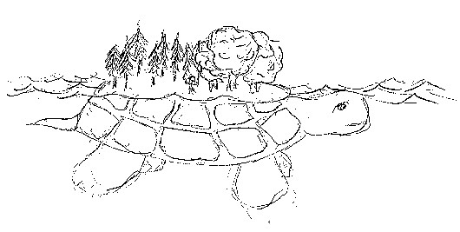Academic dishonesty, including plagiarism, cheating, and fabrication, will not be tolerated. If outside sources are ever used, you **must give an appropriate citation using MLA style**. Academic dishonesty will result in a 0 on the assignment and a discipline referral. A make-up assignment may be considered, with a score of 50 being the highest grade possible.